MANAGE USERS AND GROUPS

MANAGE USERS

TO BEGIN WITH GO TO AZURE PORTAL AND SEARCH FOR USERS. IF YOU ALREADY HAVE USERS DEFINE AS I DO BELOW YOU CAN MANAGE THE USER/S BY DOUBLE CLICKING ON THE DESTINED USER.

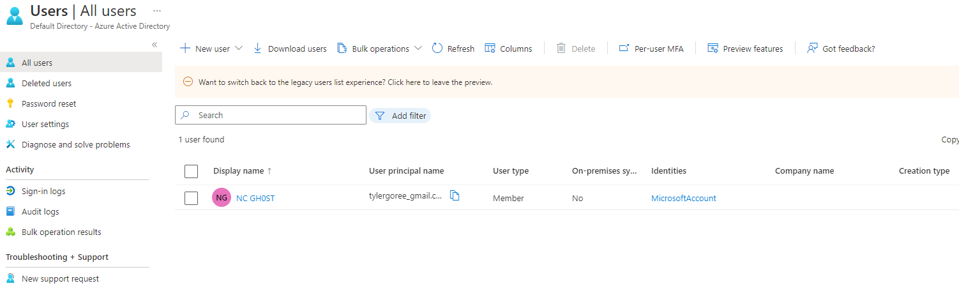

IF YOU NEED TO ADD A USER, ON THE ALL USERS DEFAULT PAGE SELECT THE + NEW USER. AS SHOW BELOW, YOU SELECT THE USER TYPE YOUR GOING TO START WITH AS IN MANAGED OR GUEST (INVITED EXTERNAL USER)

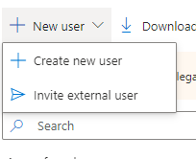

I CHOOSE TO MAKE A REGULAR USER AS SHOWN BELOW ITS PRETTY STRAIGHT FORWARD IN FOLLOWING THE WIZARD STEPS.

I CHOOSE A NAME OF PETER PAKER. I COULD HAVE GAVE PETER A ACTUAL PASSWORD MEETING THE COMPLEXITY REQUIREMENTS, BUT FOR THIS LAB I WENT WITH A AUTO GENERATED PASSWORD.

I DIDN’T ADD ANY ROLES AT THIS TIME AS THIS WAS A DEFAULT DIRECTORY, BUT I COULD HAVE SELECTING THE WORD “USER” AND BROWSING THROUGH TILL I FIND THE NECESSARY ROLES.

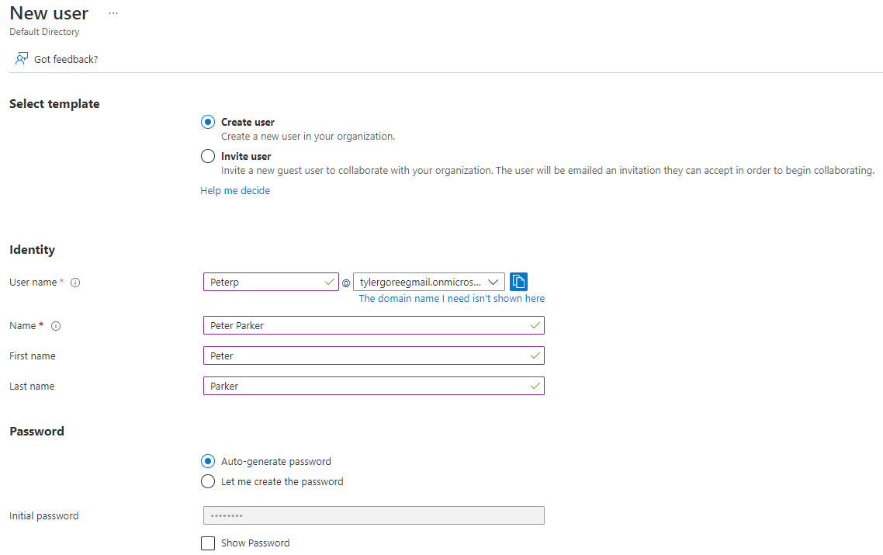

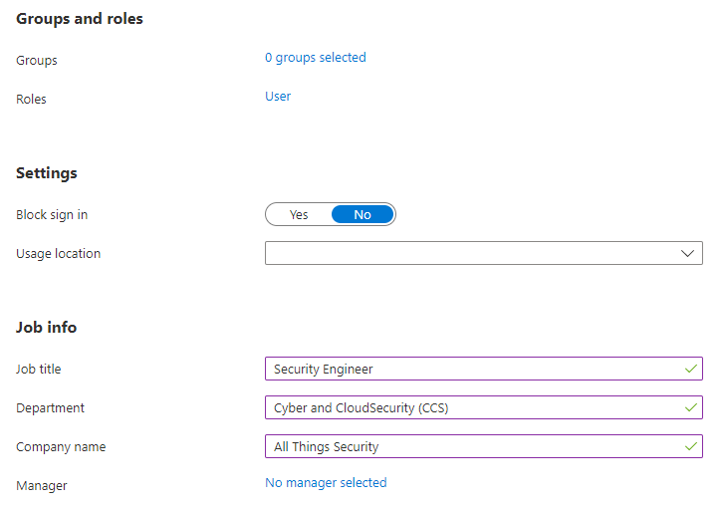

FOR GUEST USERS YOU WILL NEED TO SEND THEM An INVITE AS SHOWN BELOW.

IT STILL FOLLOWS THE SAME PAGE AS A NORMAL, BUT THEY HAVE TO ACCEPT an INVITATION TO JOIN. AFTER ACCPETING THE INVITE THE USER, IN THIS CASE PETER WILL NEED TO TWO- FACTOR AUTHENTICATE WHICH REQUIRES THE MICROSOFT AUTHENTICATOR APP WHERE YOU HAVE TO SUPPLY THE NUMBER PROVIDED BY THE APP.

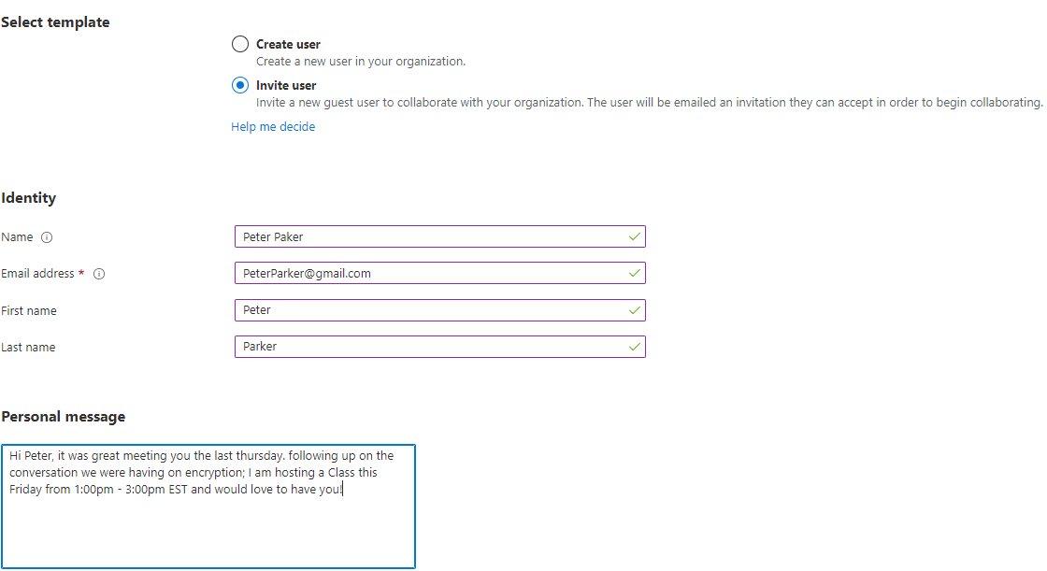

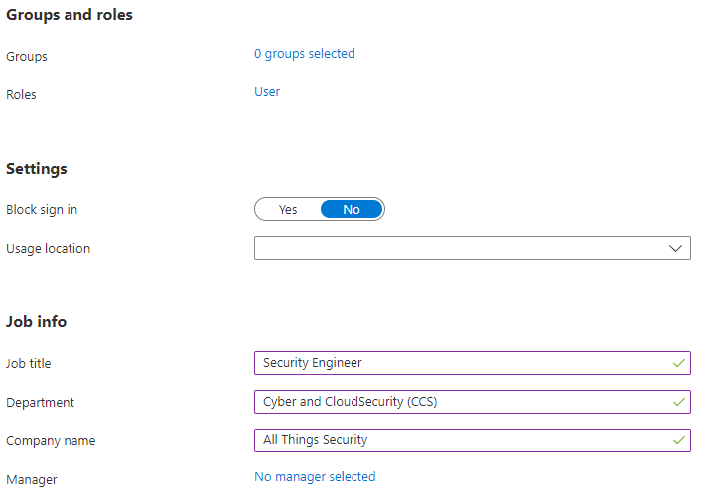

MANAGE GROUPS

TO START WITH GO INTO AZURE PORTAL AND SEARCH FOR GROUPS. IF YOU ALREADY HAVE GROUPS DEFINED YOU WILL SEE THE GROUPS LISTED WHERE YOU CAN MANAGE. IF YOU ARE NEW TO AZURE OR HAVE A NEW CLEAN ACCOUNT YOU WILL NEED TO MAKE SOME GROUPS AS I AM DOING BELOW.

TO MAKE A GROUP AS I AM DOING BELOW YOU JUST HAVE TO SELECT +NEW GROUP AND FILL IN YOUR INFORMATION AS I DONE SO BELOW

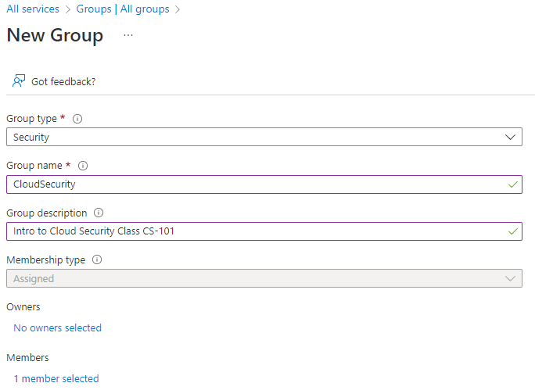

NOTE: FOR MORE INFORMATION CHECKOUT [Create and manage groups - Learn | Microsoft Docs](https://docs.microsoft.com/en-us/learn/modules/manage-users-and-groups-in-aad/4-groups)